**House2Home**

**House Renovation System**

# **Description**

# The Home Renovation System project provides a comprehensive and user-friendly solution for managing home renovation services. This application, built using Java Swing for the graphical user interface and file handling for data persistence, effectively addresses the needs of both clients and administrators.

**Packages Used**

The code uses the following packages:

* javax.swing.* for creating the graphical user interface components like JFrame, JButton, JTextArea, etc.
* java.awt.* for setting the colors, layout, and event handling.
* java.awt.event.* for handling action events on buttons.
* java.io.* for reading from and writing to files to manage data persistence.

# **Classes:**

1. AdminLoginFrame
2. AdminSignUpFrame
3. ClientHomeFrame
4. BillGenerationFrame
5. AdminHomeFrame
6. HomeDetailFrame
7. ViewRequestsFrame
8. ClientLoginFrame
9. ClientSignUpFrame
10. EditProfileFrame
11. MainFrame
12. ManageServicesFrame
13. ServiceSelectionFrame
14. WorkRequestFrame

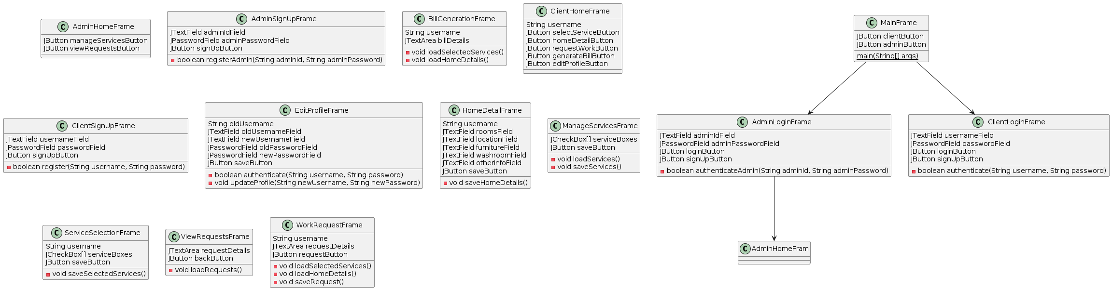**UML**

**Concepts Used:**

* File-Handing
* Exception-Handling
* GUI
* Inheritance
* Arrays
* Interfaces
* Arrays
* Constructors
* Event-Based Programming

**Classes:**

**AdminHomeFrame**

The AdminHomeFrame class creates a graphical interface for administrators. It features two main buttons: "Manage Services" and "View Work Requests". Clicking these buttons navigates the user to corresponding frames for managing services and viewing work requests, respectively. The frame is set with a specific size and design elements to ensure consistency and a user-friendly experience.

**AdminLoginFrame**

The AdminLoginFrame class provides a login interface for administrators. It includes fields for admin ID and password, and buttons for login and sign-up. When the login button is pressed, it verifies the credentials against stored admin data. If authenticated, it opens the admin home frame; otherwise, it displays an error message. The sign-up button redirects to the admin sign-up frame.

**AdminSignUpFrame**

The AdminSignUpFrame class allows new administrators to sign up. It includes fields for admin ID and password, and a sign-up button. When the button is pressed, it checks if the admin ID already exists and, if not, saves the new admin data and redirects to the admin login frame. If the ID exists, it shows an error message.

**BillGenerationFrame**

The BillGenerationFrame class generates a bill for a specific user. It displays selected services and home details by reading data from corresponding files. The bill is shown in a text area within the frame, providing a detailed breakdown of the services and associated costs.

**ClientHomeFrame**

The ClientHomeFrame class offers a home interface for clients. It includes several buttons for various actions: selecting services, detailing home information, requesting work, generating bills, and editing profiles. Each button navigates to the respective frame for performing the action, enhancing the client’s experience with easy navigation.

**ClientLoginFrame**

The ClientLoginFrame class provides a login interface for clients. It features fields for username and password, along with login and sign-up buttons. The login button verifies the credentials against stored client data. If authenticated, it opens the client home frame; otherwise, it shows an error message. The sign-up button redirects to the client sign-up frame.

**ClientSignUpFrame**

The ClientSignUpFrame class facilitates the registration of new clients. It includes fields for username and password and a sign-up button. Upon pressing the button, it checks if the username already exists. If not, it saves the new client data and redirects to the client login frame. If the username exists, it displays an error message.

**EditProfileFrame**

The EditProfileFrame class allows clients to edit their profiles. It includes fields for old and new usernames and passwords, and a save button. The save button verifies the old credentials, then updates the profile with the new information if authenticated. It then redirects to the client home frame, ensuring the client's data is up-to-date.

**HomeDetailFrame**

The HomeDetailFrame class enables clients to provide home details. It includes fields for various home-related information and a save button. When the save button is pressed, it saves the home details to a file and redirects to the client home frame. This helps in personalizing the client’s experience based on their home setup.

**MainFrame**

The MainFrame class serves as the entry point of the application, offering buttons for client and admin logins. Clicking the client button opens the client login frame, while clicking the admin button opens the admin login frame. It ensures a clear starting point for both types of users to access their respective functionalities.

**ManageServicesFrame**

The ManageServicesFrame class allows administrators to manage available services. It includes checkboxes for different services and a save button. When the save button is pressed, it saves the selected services to a file and redirects to the admin home frame. This helps administrators control the services offered by the application.

**ServiceSelectionFrame**

The ServiceSelectionFrame class enables clients to select services they want to avail. It includes checkboxes for various services and a save button. When the save button is pressed, it saves the selected services to a file and redirects to the client home frame, allowing clients to customize their service choices.

**ViewRequestsFrame**

The ViewRequestsFrame class allows administrators to view work requests submitted by clients. It displays request details in a text area and includes a back button to return to the admin home frame. This helps administrators manage and respond to client requests efficiently.

**WorkRequestFrame**

The WorkRequestFrame class enables clients to request work based on their selected services and home details. It includes a text area for request details and a request button. When the request button is pressed, it saves the request to a file and redirects to the client home frame, facilitating client work requests.

**GUI Output:**

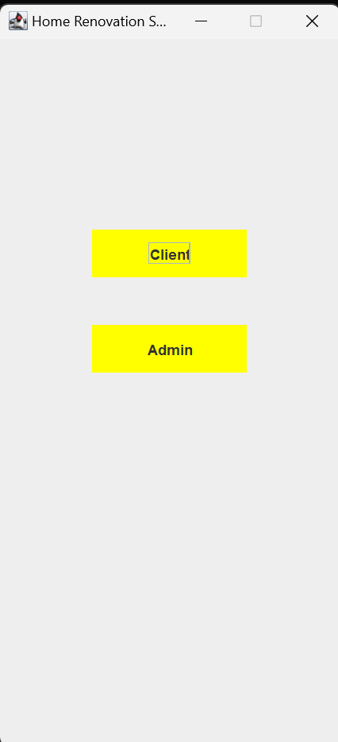

**Conclusion:**

The system includes distinct functionalities for administrators and clients. Administrators can manage services and view client requests through intuitive interfaces, ensuring efficient service delivery and responsiveness to client needs. Clients, on the other hand, have access to a range of features including service selection, home detail entry, work request submission, bill generation, and profile management. These functionalities ensure that clients can easily customize and manage their renovation projects according to their preferences.